Major Climatic Zones of the world

Climate refers to the average atmospheric conditions found in a given area. It differs from weather conditions, which can change daily.

Climatic zone

Climate zones are areas with distinct climates, which occur in east-west direction around [the Earth](https://content.meteoblue.com/en/research-education/educational-resources/meteoscool/the-earth/), and can be classified using different climatic parametres. Generally, climate zones are belt-shaped and circular around the Poles (see picture on the right). In some areas, climate zones can be interrupted by mountains or oceans.

The [solar radiation](https://content.meteoblue.com/en/research-education/educational-resources/meteoscool/weather/radiation/) reaches the ground on different parts of the Earth with different angles. On the equator, the sunlight reaches the ground almost perpendicularly, whilst at the poles the angle of the Sun is lower or even under the horizon during the [polar night](https://content.meteoblue.com/en/research-education/educational-resources/meteoscool/general-climate-zones/cold-zone/polar-day-polar-night/).

[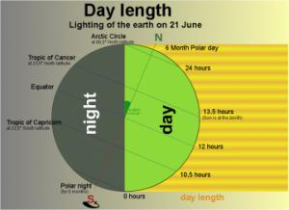](https://content.meteoblue.com/en/research-education/educational-resources/meteoscool/general-climate-zones/Daylength_lightbox.jpg)

Throughout the [seasons](https://content.meteoblue.com/en/research-education/educational-resources/meteoscool/the-earth/seasons/), the position of the Sun to the Earth and thus the angle of incidence of the sunlight also change. The angle of the Sun at noon varies from perpendicular (90°) within the tropics up to horizontal (0° = Sun does not or only partially appear on the horizon) within the polar circle. Thus, the sunlight warms up the Earth around the equator much more strongly than at the poles. Due to [temperature](https://content.meteoblue.com/en/research-education/educational-resources/meteoscool/weather/temperature/) differences caused by the differences in radiation, recurring climatic conditions develop, such as winter and summer. These conditions are characterised by a certain amount of precipitation in summer or a certain average air temperature.  
Different climatic conditions, which arise regularly in certain areas, are summarised and described in the classification below.

# Climate zones and weather

## What is the difference between weather and climate?

**Weather** describes the **day-to-day conditions** of the atmosphere. Weather can change quickly - one day it can be dry and sunny and the next day it may rain.

**Climate** describes **average weather conditions** over **longer periods** and over **large areas**.

The map below shows the world climatic zones.

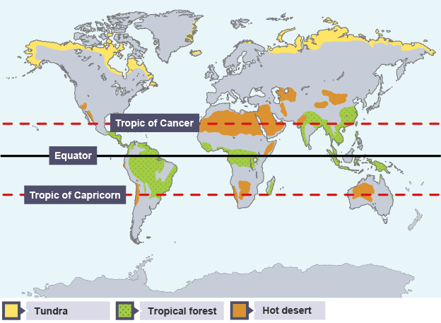

Classificati **major climate zones:**

* [Tropical zone](https://content.meteoblue.com/en/research-education/educational-resources/meteoscool/general-climate-zones/tropical-zone/) from 0°–23.5°(between the tropics)

In the regions between the equator and the tropics (equatorial region), the solar radiation reaches the ground nearly vertically at noontime during almost the entire year. Thereby, it is very warm in these regions. Through high temperatures, more water evaporates and the air is often moist. The resulting frequent and dense [cloud cover](https://content.meteoblue.com/en/research-education/educational-resources/meteoscool/weather/clouds/) reduces the effect of solar radiation on ground temperature.

* [Subtropics](https://content.meteoblue.com/en/research-education/educational-resources/meteoscool/general-climate-zones/subtropical-zone/) from 23.5°–40°

The subtropics receive the highest radiation in summer, since the Sun's angle at noon is almost vertical to the Earth, whilst the cloud cover is relatively thin. These regions receive less moisture (see [trade winds](https://content.meteoblue.com/en/research-education/educational-resources/meteoscool/large-scale-weather/trade-winds/)), what increases the effect of radiation. Therefore, most of the [deserts](https://content.meteoblue.com/en/research-education/educational-resources/meteoscool/vegetation/deserts/) in the world are situated in this zone. In winter, the radiation in these regions decreases significantly, and it can temporarily be very cool and moist.

* [Temperate zone](https://content.meteoblue.com/en/research-education/educational-resources/meteoscool/general-climate-zones/temperate-zone/) from 40°–60°

In the temperate zone, the solar radiation arrives with a smaller angle, and the average temperatures here are much cooler than in the subtropics. The seasons and daylength differ significantly in the course of a year. The climate is characterised by less frequent extremes, a more regular distribution of the [precipitation](https://content.meteoblue.com/en/research-education/educational-resources/meteoscool/weather/precipitation/) over the year and a longer [vegetation](https://content.meteoblue.com/en/research-education/educational-resources/meteoscool/vegetation/) period - therefore the name "temperate".

* [Cold zone](https://content.meteoblue.com/en/research-education/educational-resources/meteoscool/general-climate-zones/cold-zone/) from 60°–90°

The polar areas between 60° latitude and the poles receive less heat through solar radiation, since the Sun has a very flat angle toward the ground. Because of the changes of the Earth axis angle to the Sun, the daylength varies most in this zone. In the summer, polar days occur. Vegetation is only possible during a few months per year and even then is often sparse. The conditions for life in these regions are very hard.

### Equatorial Climate Characteristics

#### Equatorial climate distribution

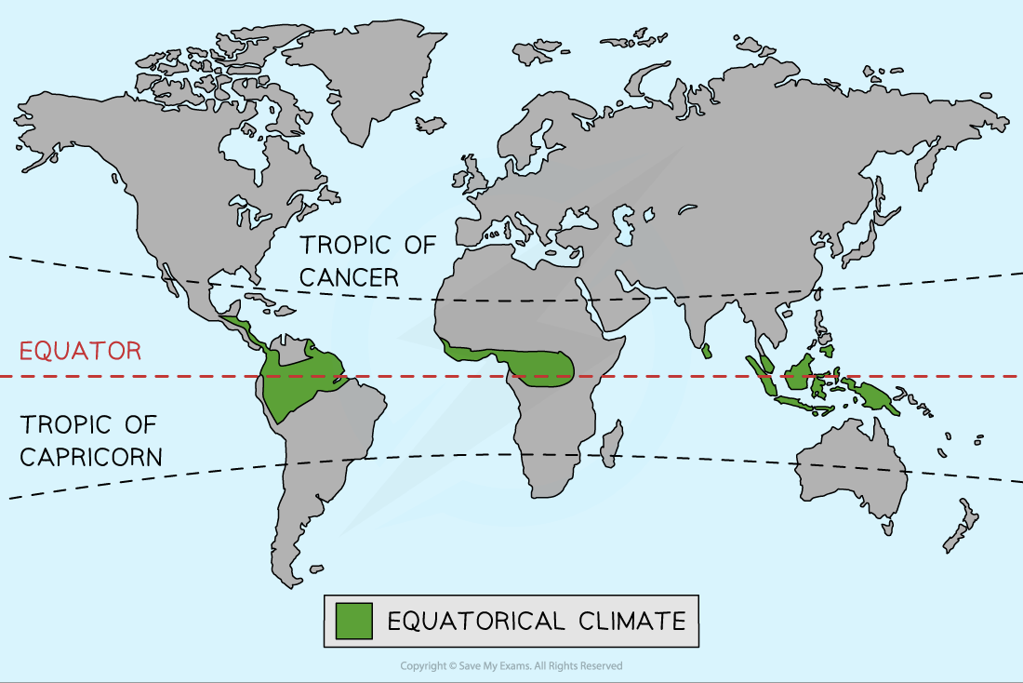

**Distribution of the Equatorial Climate**

Location: It is mainly found between 50 North and South of Equator, but extend to 100 north and south of 00. It is well developed in central Africa, West Africa in the southern Ghana, southern parts of Nigeria, Cameroon, Gabon, Republic of Congo, Democratic Republic of Congo, Guinea, southern Ivory Coast, east coast of coastal Malagasy Republic and east African highlands. It is characterized by the following:

* It has uniformly warm to hot temperatures of about 260C, small (low) annual range of about 20C to 30c, and small diurnal range of 10c to 80c. The temperature ranges between 220c - 290c.
* Heavy and well distributed rainfall throughout the year with a double maxima/two peaks of rainfall: march-may (long rains) and October- November (short rains) and April is the wettest month
* The rainfall is normally conventional type of rainfall from towering cumulonimbus clouds, accompanied by thunderstorms and lightening; and rainfall occurs in the afternoons and evenings.
* Humidity is very high throughout the year and relative humidity is constantly high over 80%.
* Heavy clouds cover throughout the year.
* The sun rising is between 6:00am and 6:30am and setting is between 6:00pm-6:30pm (almost equal).
* The mid-day sun is always near vertical and overhead twice a year at the equinoxes.
* Morning weather is often quite sunny and clear, but heat builds up during the day until by about 2.00pm. Cumulus clouds develop growing into towering Cumulo nimbus which gives heavy rain.
* There is little or no dry season. Summary: Hot and wet throughout the year.

#### Equatorial climate characteristics SUMMARY

|  |  |
| --- | --- |
| **Characteristics** | **Equatorial Climate** |
| **Location** | * Low latitudes * Within the Tropics 23.5° north and south of the equator * Amazon in South America, New Guinea, South-east Asia, Zaire Basin |
| **Annual Precipitation** | * Over 2000mm |
| **Temperature Range** | * low range of mean monthly temperatures - 26-28°C * Constant high temperatures * Diurnal range is about 7oC |
| **Seasons** | * No seasons - hot and wet all year round |
| **Humidity** | * High, usually over 75-80% |
| **Prevailing winds** | * Winds blow into the equatorial region from high pressure areas to the north and south. * The winds from the north blow from the north-east and the winds from the south blow from the south-east. * The winds are known as the**trade winds** |

**GRAPH FOR THE CLIMATE**

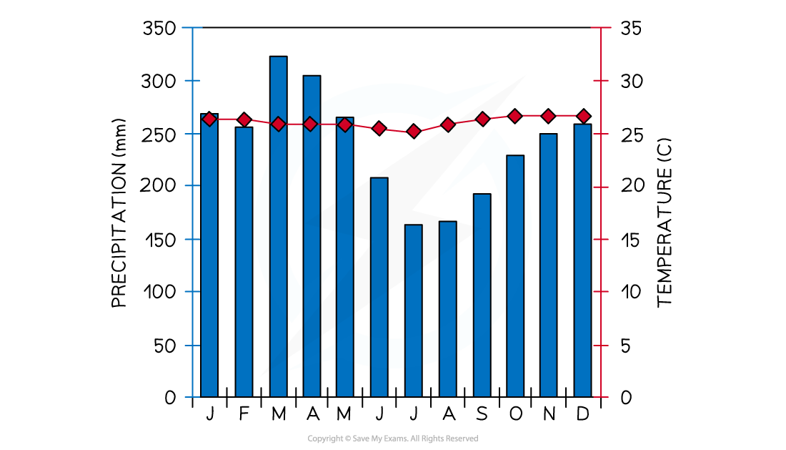

**Climate graph for Iquitos, Peru**

#### Factors influencing the equatorial climate

There are a range of factors which influence the climate including:

* The midday sun is almost directly overhead all year meaning there is maximum insolation
* Low pressure all year which leads to rising air, condensation, cloud formation and high precipitation levels
* Dense vegetation cover leads to high levels of evaporation and transpiration
* The warm air stores large amounts of water vapour until the temperatures start to cool in late afternoon which then leads to heavy, daily convectional rainfall

**Economic activities carried out in this type of climate**

* Growing of annual and perennial crops/traditional and non-traditional crops on both small and large farming
* Livestock farming
* harvesting the forest resources/lumbering
* Mining and quarrying
* Art and craft
* Fishing,
* Tourism and wild life conservation

### *Hot Desert Climate Characteristics*

#### Hot desert climate distribution

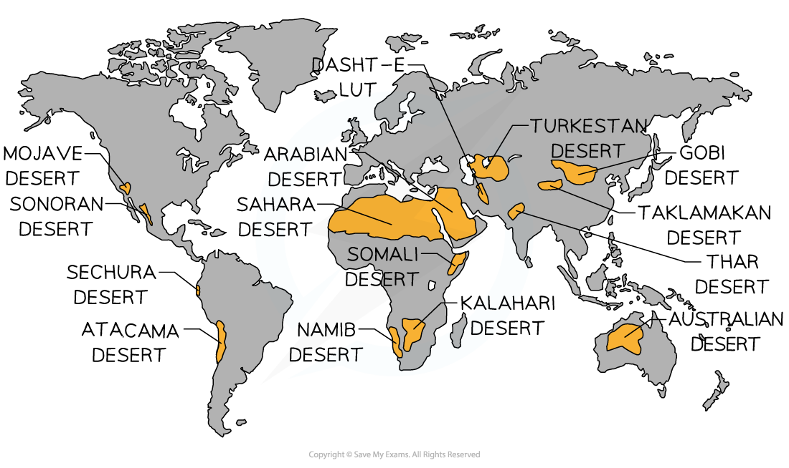

**Distribution of the Hot Desert Climate**

**Location**

They occur on the western side of Africa extending into the interiors, where the trade winds originate from over the land, blowing to the oceans. The aridity of the hot deserts is mainly due to the effects of the off-shore trade winds; hence they are also called the Trade Wind Deserts. The tropical deserts are

* Sahara Desert which extends from Senegal to Egypt and it is the largest single stretch of the desert, Namibia and Kalahari Deserts.

They are characterized by:

* The rainfall is generally less than 250 mm per year, scarce and unreliable.
* Rain normally occurs as violet thunderstorms of convectional type and may evaporate as soon as it stops raining.
* It falls suddenly and pours continuously for a few hours over small areas.
* The temperatures are extremely hot over 350c throughout the year.
* Days are unbearably hot and the nights are cold which brings about high daily temperature ranges
* Humidity is low

#### Hot desert climate characteristics

|  |  |
| --- | --- |
| **Characteristics** | **Hot Desert** |
| **Location** | * 15°- 30°north and south of the equator (tropical and sub-tropical) * North Africa - Sahara, Southern Africa - Kalahari and Namib, Australia. Middle East |
| **Annual Precipitation** | * Below 250mm |
| **Temperature Range** | * Daytime temperatures can reach 50°C but average around 25°C * Night-time temperatures below 0°C * Diurnal range is large up to 45°C * Annual range is around 15°C |
| **Seasons** | * Summer and winter |
| **Humidity** | * Low often between 10-30% |
| **Prevailing Winds** | * The winds are offshore blowing from the east across the land, so they do not collect any moisture |

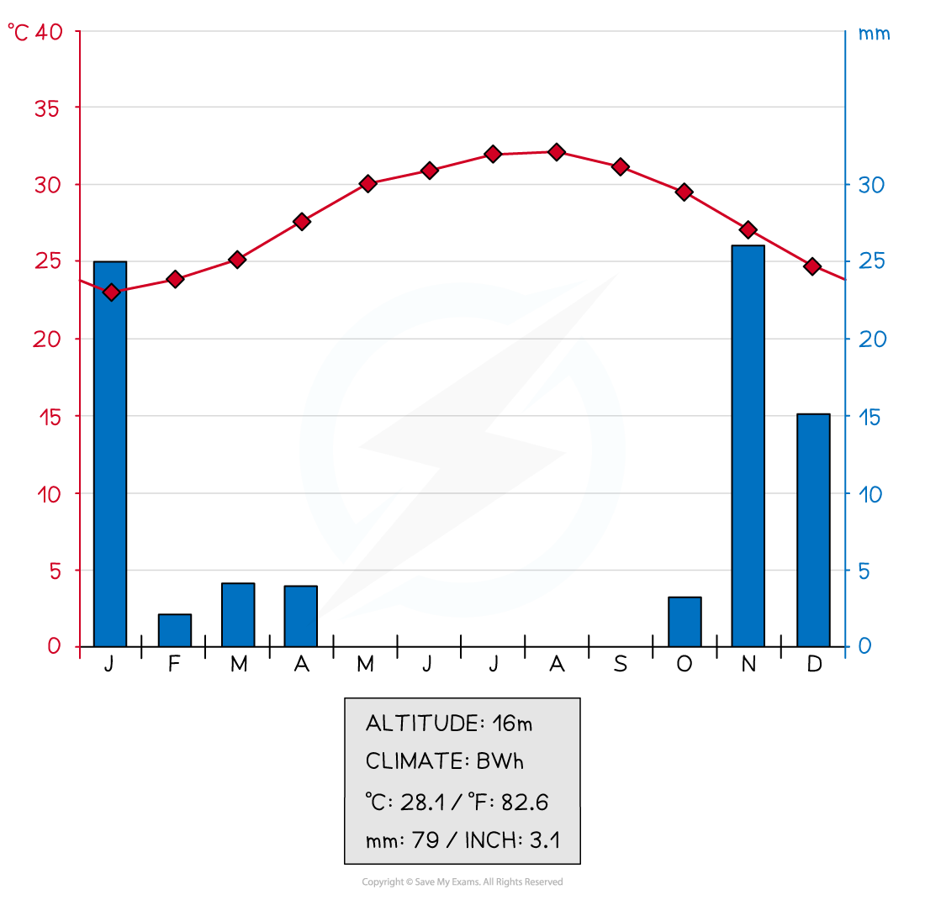

**Climate Graph for Jeddah, Saudi Arabia**

#### Factors influencing the hot desert climate

* High pressure all year which means the air is descending and warming so precipitation does not occur because the air is not rising
* Prevailing winds are often from over land masses which means they contain little moisture
* Some deserts are in a rain shadow so there is little rainfall
* Cold ocean currents on the west side of continents may reduce summer temperatures due to the cooling effect of the ocean

#### Influence of pressure systems

* Hot deserts form between 15o- 30onorth and south of the equator as a result of the atmospheric pressure systems
  + Air rises at the equator and when it reaches the upper atmosphere it moves north and south
  + The air cools and starts to sink
  + This creates a zone of high pressure at about 30o north and south of the equator
  + Due to the sinking air, warm air cannot rise, condense and form clouds. This results in high aridity

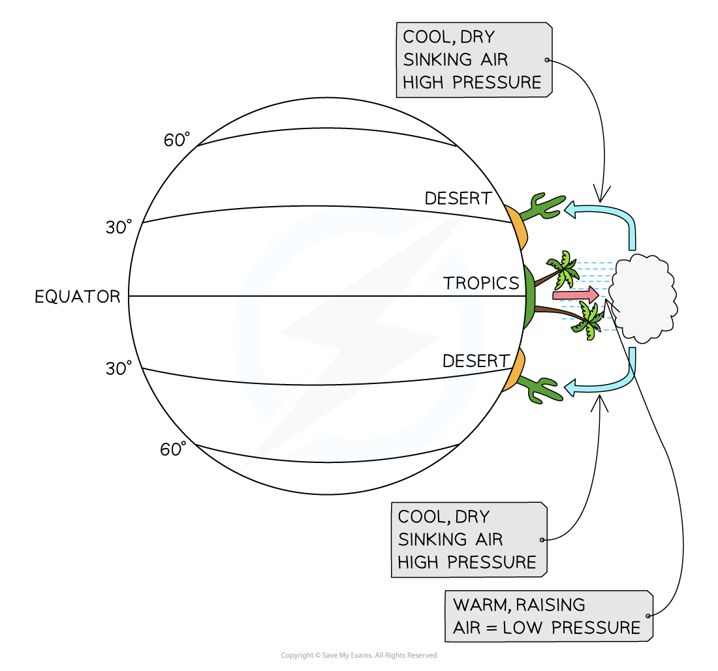

Why is it hot at the Equator and cold at the poles?

The diagram below helps to explain why the poles are colder than the Equator.

The sun's rays hit the Equator more directly and spread over a smaller surface area than at the poles

Why is it hot at the Equator and cold at the poles?

* Sunlight hits the Earth most directly at the Equator. The curve of the Earth means that sunlight is spread over a wider area the further you move from the Equator. Sunlight hits a **smaller surface area** at the Equator so **heats up quickly** compared to the poles.
* There is **less atmosphere to pass through** at the Equator compared to the poles. This means **more heat from the sun** makes it to the surface of the Earth.
* The changing tilt of the Earth means that the **Equator faces the sun all year round** whereas the poles can be darkness for six months of the year. This keeps the Equator's temperatuer high all year round. The temperature at the poles changes between summer and winter.

This results in different climate zones in different parts of the Earth:

* **Tundra** regions located **at the poles** are cold for the majority of the year.
* **Deserts** located **around the Equator** are hot all year round.
* **Tropical rainforests** are located **between the tropics** so are hot and humid

# Location and climate

## Location of tropical climate

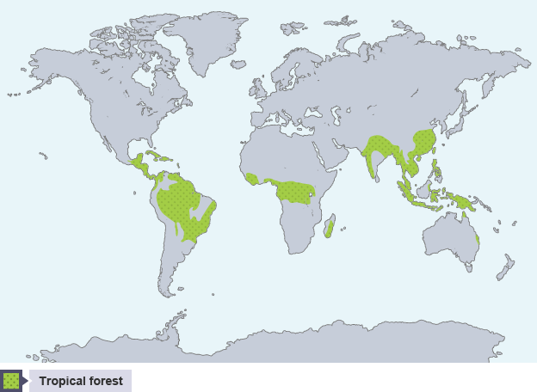

Tropical rainforests are found near the Equator. Places which experience a tropical rainforest climate include parts of:

* Central America, eg Costa Rica
* South America, eg Brazil
* Central Africa, eg Kenya
* South-East Asia, eg Borneo

Watch this video to find out more about tropical rainforest climate.

Rainforest processes - Costa Rica

## Description of the tropical climate

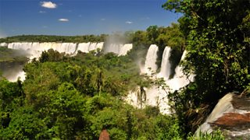

Rainforests are located in the tropical climate region. They are hot and wet all year round – this creates a humid climate.

The annual rainfall is high as it rains almost every day. The temperatures are constant all year round – the temperature range is usually only a few degrees. There are no seasons.

The climate graph shows average rainfall and temperatures in Manaus, located in the Amazon rainforest in Brazil. The highest monthly rainfall is in March with over 300 mm and the lowest rainfall occurs in August with under 50 mm.

Temperatures vary little throughout the year. The highest monthly temperature is 29°C which occurs in September. The lowest monthly temperature is 26°C which occurs in December and January. The annual temperature range is 2°C.

**Hot, Wet Equatorial Climate**

Wet equatorial climate, major Köppen climate type characterised by consistently high temperatures (around 30 °C [86 °F]), abundant precipitation (150-1,000 cm [59-394 inches]), heavy cloud cover, and high humidity, with little annual temperature variation.

1. Equatorial Climate Location

The hot, wet equatorial climate is found between 5° and 10° north and south of the equator. Its maximum extent is located in the lowlands of the Amazon, the Congo, Malaysia, and the East Indies.

2. Equatorial Climate Precipitation

Throughout the year, precipitation is abundant and evenly distributed. The annual average is always greater than 150 cm. In some areas, the annual average may reach 250-300 cm. There is no month that does not have rain. The monthly average is usually greater than 6 cm. There is a lot of evaporation, and convection air currents form, which leads to heavy thunderstorms in the afternoons.

3. Equatorial Climate Climatic Conditions

The primary feature of this type of climate is its temperature uniformity throughout the year. This manifests in the form of no winter season. The mean monthly temperature hovers around 27°C with minimal variation. Cloudiness and heavy precipitation moderates the daily temperature. The diurnal temperature range is small, as is the annual temperature range. This climatic zone is subject to seasonal shifting due to seasonal shifts in pressure and wind belts caused by the sun’s northward and southward migration. Two major properties characterize it.

Uniform and high temperature throughout the year, and

Uniform and adequate rainfall throughout the year is received through the convective mechanism.

Precipitation is heavy (between 60 to 100 inches). It is well distributed throughout the year. There is no month without rain and a distinct dry season is absent.

4. Equatorial Climate Soil

The majority of the soil is nutrient-deficient.

A thin layer of fertile soil forms on the surface as the dead leaves decay.

Because of its high iron content, it is reddish in colour.

Excessive rains quickly flush nutrients out of the soil.

5. Equatorial Climate Natural Vegetation

It supports tropical rainforests. For instance, Selvas in the Amazon tropical rain forest. It comprises a multitude of evergreen trees. These include those that yield tropical hardwood, e.g., mahogany, ebony, greenheart, and cabinet wood. Lianas, epiphytic and parasitic plants are also found. Mangroves thrive in coastal areas and brackish swamps. The tropical rainforest grows like a thick canopy of foliage from the top. It is broken only where it is crossed by large rivers or cleared for cultivation. It lacks dense undergrowth as the trees do not allow sunlight to reach the ground.

6. Equatorial Climate Wildlife

The equatorial region is not only home to lush and diverse plants, but also to a diverse range of wildlife. Plant diversity supports a wide range of animals, birds, and insects. The African elephant and the Jaguar are among the fauna found in this region. The Congo basin is home to mountain gorillas, lowland gorillas, chimps, and numerous bird species. Poison dart frogs, margay and collared anteaters, sloths, toucans, spider monkeys, and flying frogs are among the other animals.

7. Equatorial Climate Life and Economy

The forests support the most primitive people, such as hunter-gatherers, and the more advanced ones practice shifting cultivation. Food is abundantly available. Shifting cultivation is practised by clearing the forests.  Indian tribes collect wild rubber in the Amazon Basin. The Pygmies gather nuts in the Congo Basin. The Orang Asli make different types of cane products and sell them to people in villages and towns in the jungles of Malaysia. Read More: Anticyclones

Equatorial Climate Region UPSC

Excessive heat and humidity are hazardous to people’s health. As a result of climate change, the people in this region have become more vulnerable. While the hot and humid equatorial rainforest climate promotes plant growth, it also promotes the growth of bacteria and pests. These, in turn, are to blame for the equatorial region’s high prevalence of illness. Among the 58 diseases spread by vectors in this area are malaria, lymphatic filariasis, and dengue fever

# Temperate Zone

# Definition and Characteristics

Geographers divide the earth in several different ways. One of the main methods to divide the earth is by dividing it into bands that are parallel to the equator. These various bands help to describe the climate of the regions of the earth. The farther a place is from the equator, it will be colder in the climate. Actually, we can divide the regions of Earth that can be divided into zones based on their proximity to the equator. These are tropical zone, temperate zone, and polar zones.

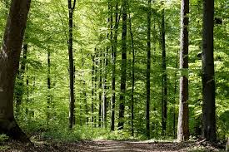

### **Parallels of Latitude**

[Parallels of latitude](https://www.toppr.com/guides/geography/globe-latitudes-and-longitudes/longitudes/) run from zero degrees at the equator to 90 degrees at the North Pole and 90 degrees at the South Pole. Degrees of latitude increase as we move away from the equator and toward the poles.

The temperate zone lies in the middle latitudes. Latitude is the main factor in classifying zones because it correlates to the amount of sunlight an area receives.

### **Climate Zones**

Wladimir Koppen has identified and defined the various climate zones of Earth. These are tropical, dry, temperate, continental, polar and highland. Climate zones are classified based on the average temperature, amount of rainfall and [type of climate](https://www.toppr.com/guides/geography/climate/climate-of-india/) they have.

Latitude, elevation and the presence of nearby mountains or large water bodies help to determine the climate zone. This is because of their effects on weather patterns.

### **Temperate Zones**

The temperate zone mainly lies between the tropics and the Polar Regions. It experiences a wide range of temperatures and precipitation where four distinct seasons are common. Every continent but except Antarctica has at least a small portion of land in the temperate zone.

Regions that are covered exclusively in the temperate zone include the continental U.S., most of Canada and Europe, Central Asia, southern South America, and southern Australia.

Temperate regions are found between the Tropic of Cancer and Tropic of Capricorn. It generally having has four different seasons such as spring, summer, autumn, and winter.

The most popular climate to live in as it does not experience the wide variations of some of the more extreme climates. The ability to grow a large variety of crops and fruit is a major source of income in these regions. Grain crops such as wheat, barley, and oats are very much produced.

Pears, apples, strawberries and other soft fruit are grown to consume as well as sell. Deciduous trees in many different areas are giving way to coniferous trees. In these areas, the temperatures are lower for example in hilly or mountainous regions.

#### **Some Characteristics based on various parameters are as follows**

**Area:**Lies between the cold zone and the subtropical zone (40° to 60°)

**Sun path:** Maximum is 73°, the minimum is 0° at the Arctic Circle.

**Average temperature:** Between zero and 20°C

**Minimal temperature:** -40°C

**Maximal temperature:** +40°C

**Radiation:**The balance is negative

**Day length:**4 to 16 hours  and   8 to 12 hours at 50°N

**Precipitation:** Varies from 300 to 2000 mm, on the average 800 mm.

**Climate:** Warm and cold temperate

**Vegetation:** Deciduous forests, warm temperate forests, savannah

**Properties:** Extreme temperature and precipitation is rare

# 5 Major Types Of Vegetation In The World

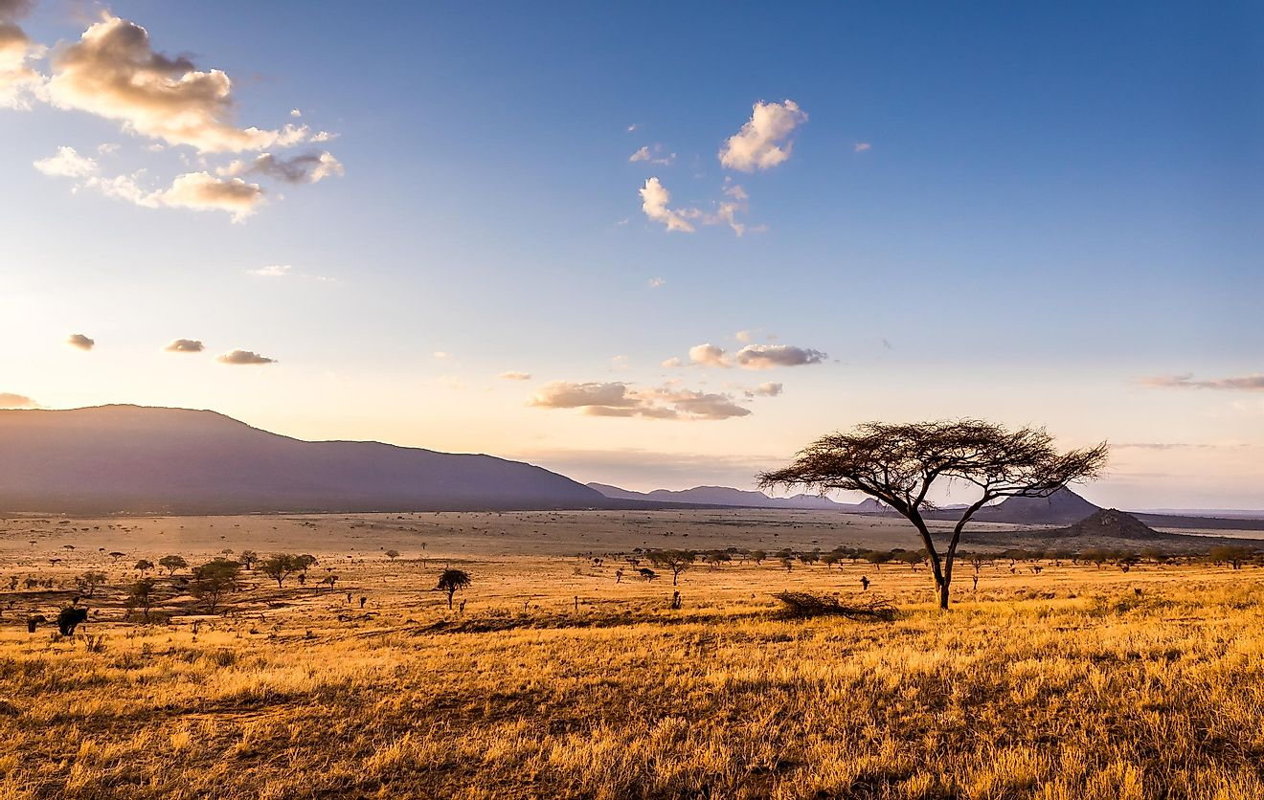Amazing sunset at savannah plains in Tsavo East National Park, Kenya

## 5. Forests

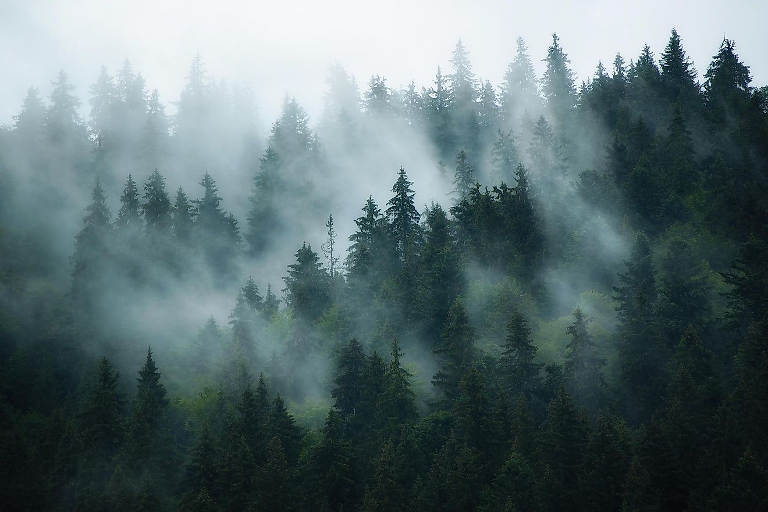Forests can emerge in almost any kind of terrain, and they can develop anywhere between sea level and high mountain ranges.

The most important factor that creates a forest is, of course, the trees. But, for something to be classified as a forest, the density of the trees and their leaves must have the ability to cover the ground, or better to say, to create shade to everything that is underneath them. Forests can emerge in almost any kind of terrain, and they can develop anywhere between sea level and high mountain ranges.

Although the vast majority of forests have a mixed population of trees, meaning there is almost always more than one type of tree growing in a particular area, we can also differentiate types of forests. Tropical forests usually grow in[the tropics](https://www.worldatlas.com/articles/what-are-the-tropics.html) (close to the Earth’s equator), while boreal forests generally thrive in much colder conditions (close to the Arctic).

## 4. Grasslands

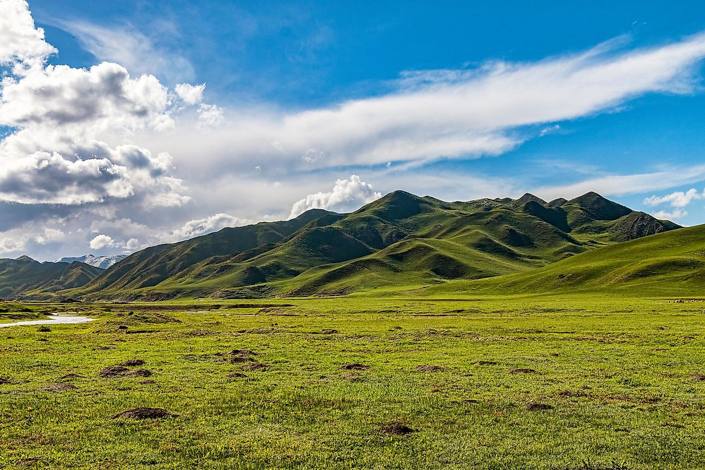Open Prairie Grasslands in Tibetan Amdo Region of Central China.

This type of vegetation can be found everywhere on Earth, except for Antarctica, which is way too cold to support the life of plants. Grasslands are vast and flat areas covered with different types of grass.

There are two main types of grasslands: temperate and tropical. Temperate grasslands appear in areas where the variations in temperature occur when the seasons change. This means that in temperate grasslands, the vegetation changes accordingly because some species prefer to grow during summertime, while others come to life [when it is cold](https://www.worldatlas.com/articles/the-coldest-temperatures-ever-recorded-on-earth.html). On the other hand, tropical grasslands, also known as savannas, prefer when it is warm and (mostly) dry throughout the year.

## 3. Tundras

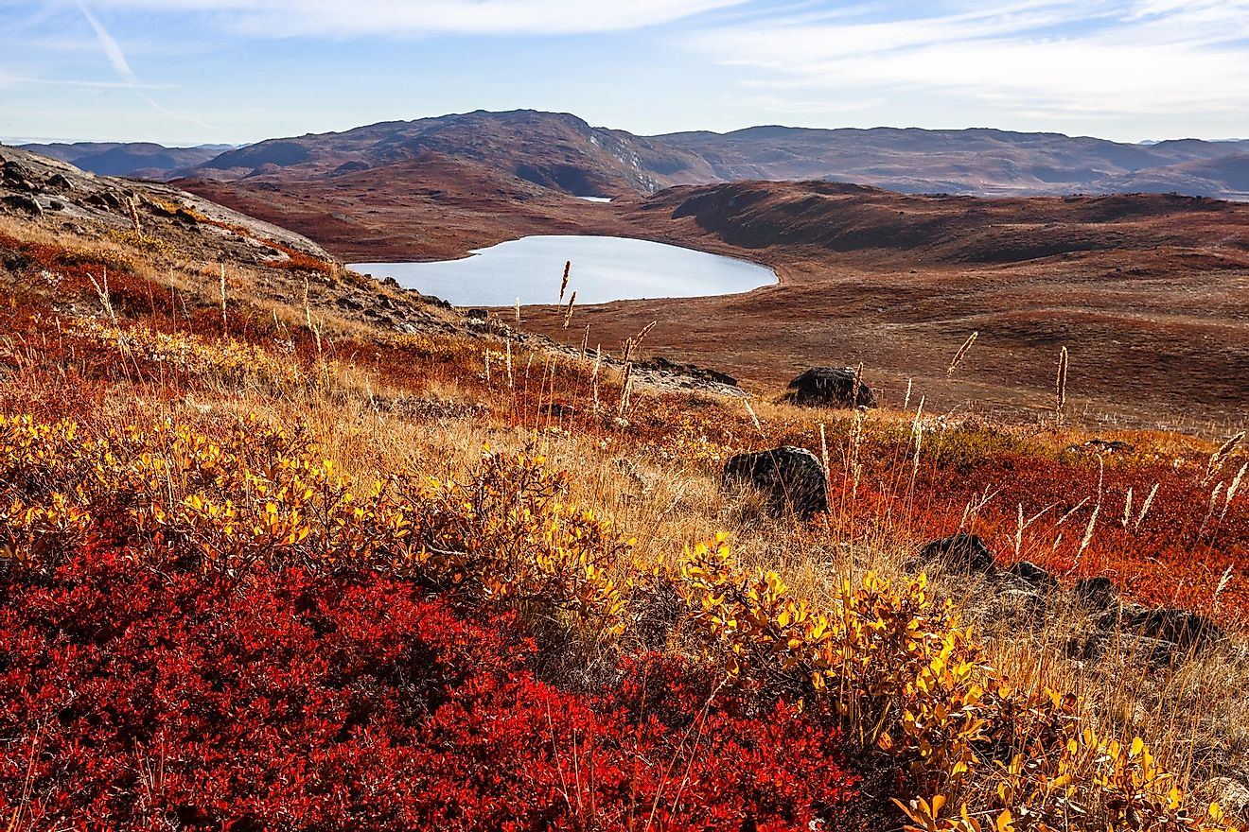Autumn greenlandic orange tundra landscape with lakes and mountains in the background, Kangerlussuaq, Greenland

Tundras appear in climate zones where the temperatures are mostly low, and unlike the previous two types of vegetation, their diversity of the population is much smaller. There are two different types of tundras: alpine and arctic.

Alpine tundras usually have a very distinct border between them and the forests. The weather that supports this vegetation is mostly very cold and harsh, and there is plenty of snow and wind as well.[Arctic tundras](https://www.worldatlas.com/articles/what-and-where-is-the-tundra.html) can be found in the northern hemisphere of Earth, where the lands are mostly frozen throughout the year. There are very few animals that can be found in these areas, but polar bears adapted to very harsh conditions of this vegetation.

## 2. Deserts

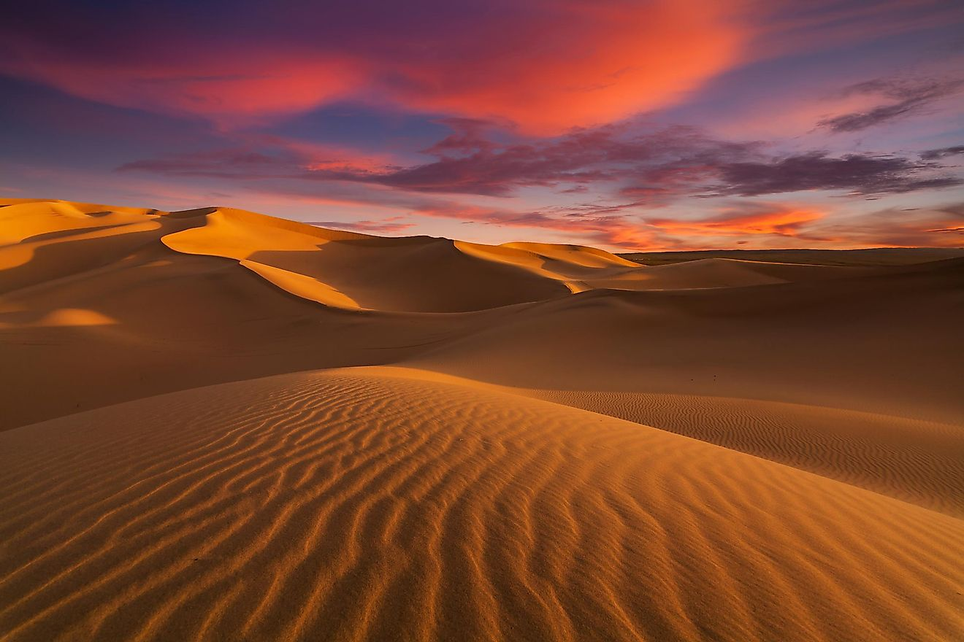The Sahara desert.

To classify something as a desert, you need to know how much precipitation is present in that area. If there are less than 10 inches of rain that falls any given year, we are talking about deserts: areas of low humidity, extremely high temperatures, and rather low temperatures in the night.

Plants and animals that live in this type of vegetation have to adapt to these hard conditions, where there is almost no water, and the food resources are scarce. But, every [desert on Earth](https://www.worldatlas.com/articles/10-largest-deserts-in-the-world.html) is not full of hot sand. The biggest desert on this planet is actually Antarctica, with nothing but ice covering the ground of the whole continent.

## 1. Ice Sheets

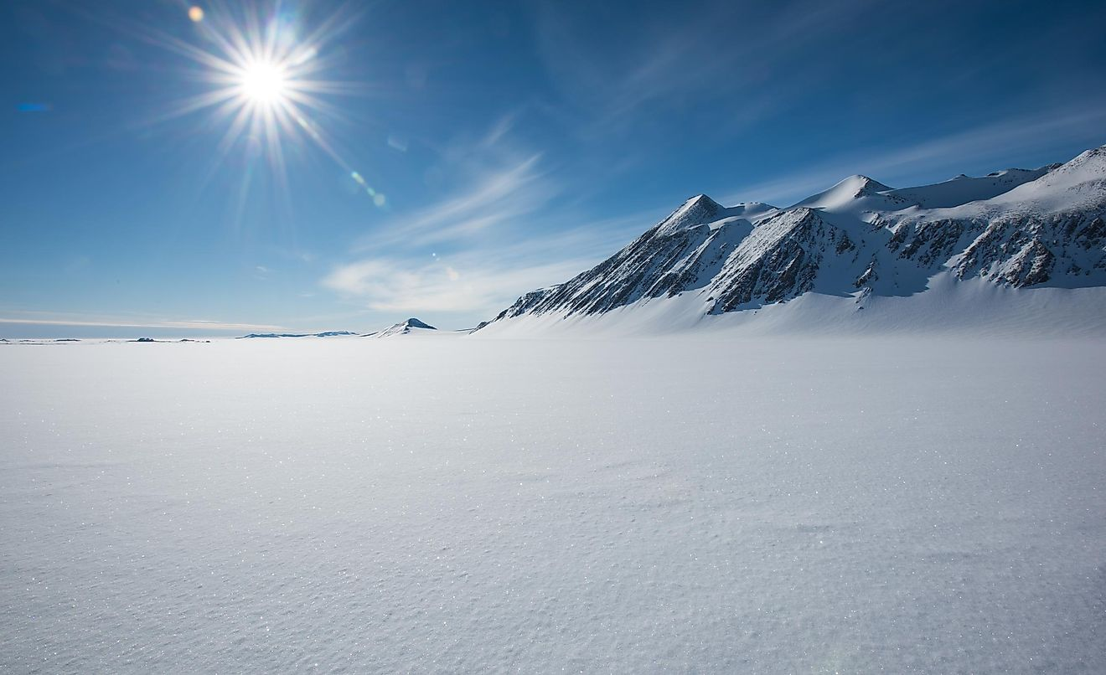Vinson Massif, Sentinel Range, Ellsworth Mountains, Antarctica

We can find only two places on Earth that allow for the creation of ice sheets: one is [Antarctica](https://www.worldatlas.com/articles/is-antarctica-a-country-who-owns-it-and-what-do-international-laws-state.html), and the other in Greenland. Ice sheets are vast areas of ice glaciers that cover more than 50,000 square kilometers. Although this is classified as a type of vegetation, there is barely any life in these areas, simply because there is almost nothing except ice there

# What factors affect climate?

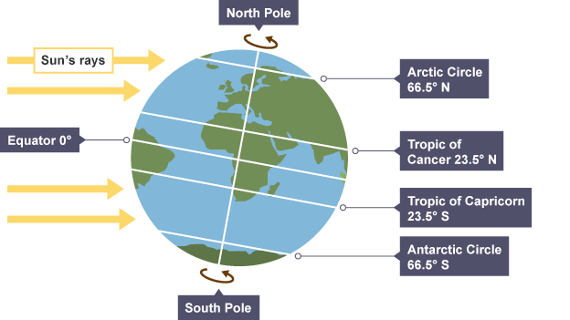

**1. Latitude or distance from the equator** – Temperatures drop the further an area is from the equator due to the curvature of the earth. In areas closer to the poles, sunlight has a larger area of atmosphere to pass through and the sun is at a lower angle in the sky. As a result, more energy is lost and temperatures are cooler.

**2. Prevailing wind** - The prevailing wind is the most frequent wind direction a location experiences. In Britain the prevailing wind is from the South West, which brings warm, moist air from the Atlantic Ocean, particularly the North Atlantic Drift. This contributes to the frequent rainfall.

# Factors affecting climate

**3. Altitude or height above sea level** - Locations at a higher altitude have colder temperatures. Temperature usually decreases by 1°C for every 100 metres in altitude. This is because air at higher altitudes is thinner with less molecules, which makes it very difficult for heat to be transferred between the molecules as they are further apart.

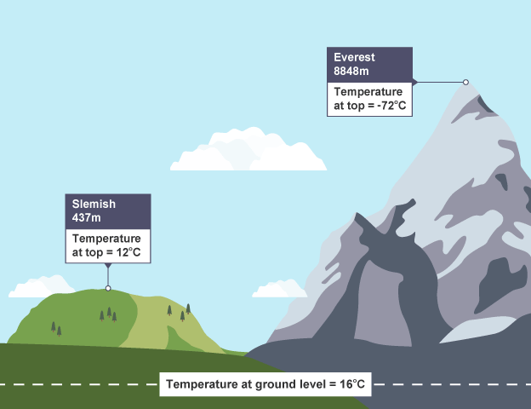

**4. Distance from the sea** – Oceans heat up and cool down much more slowly than land. This means that coastal locations tend to be cooler in summer and warmer in winter than places inland at the same latitude and altitude. Glasgow, for example, is at a similar latitude to Moscow, but is much milder in winter because it is nearer to the coast than Moscow.

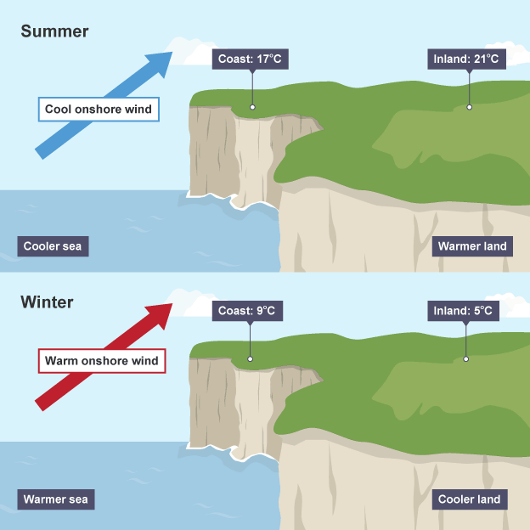

The main factors that influence the climate of Africa are: Altitude: The climatic differences in Africa are partly attributed the Altitude. The temperature drops or becomes cooler by 10C for every 150 metres of ascent. This is known as temperature Lapse rate. Altitude has a remarkable effect on temperature distribution in Africa. It influences climate as follows: Page 7 of 9 • The highland areas of Ethiopian massif, Atlas have lower temperatures because the temperatures tend to decrease with altitude at the rate of 10c after every 150 metres. This partly explains why mountain Rwenzori experience snow on its top despite its location near the equator. • High altitude areas of Africa receive heavy orographic/relief rainfall because the warm dry ascending air cool, condense, and form cumulus and cumulonimbus clouds as it ascends a mountain leading to heavy rainfall on the wind ward sides. • It also affects pressure in that atmospheric pressure decreases with an increase in altitude that is why high-altitude experience low atmospheric pressure and higher pressure on the foothills of the mountains. • There is also low humidity in the highland areas because of the low temperatures experienced in mountainous areas. • Low lying areas have high temperatures rising above 240C for example in the rift valley areas, while the mountain peaks have cool temperatures. The influence of relief Relief is the general appearance of the land of the land surface. Africa has a varied relief ranging from plains to high mountains all these have influence on the climate of Africa as follows: • Flat areas experience dry weather conditions because there are hardly any hills or mountains which could hold back winds. As a result, the winds gather speed over such areas and drive away clouds to other areas. • Highland areas like Ethiopian highlands, Cameroon highland and Atlas receive heavy rainfall due to the fact that the incoming winds are forced to rise when the blow towards the highlands and in the process cool, and the moisture condenses into orographic rainfall on the wind ward side. The leeward side is however in the rain shadow and they have arid/dry conditions as illustrated below; illustration of the relief rainfall Latitude: The latitudinal position of Africa explains the tropical nature of climate generally characterised by hot temperatures since the sun is normally over head the tropics that is the sun migrates within the tropics. This is because the concentration of the sun rays is greater within the tropical region. Places near the equator experience maximum heat from the sun and therefore, experiencing warm to hot temperatures all the year except in hilly areas. The warm to hot temperatures lead to high moisture content in the atmosphere which results into high precipitation with two peaks of rainfall or bimodal rainfall. Areas far away from the equator have one rainy season followed by a long dry season. Wind systems: Africa is placed in the global context of winds. The most influencing ones on her climates are the: North east, south east and south west prevailing/trade winds. Generally, the low-pressure trough that develops over Africa in the tropics attracts winds from centres of high pressure usually over the cooler water bodies. The winds are drawn in into the trough and converge over the tropical lands and causes convectional rainfall over many places in Africa. Activity: Draw the sketch map of Africa showing the trade winds that affect climate. At the front of the winds heavy rainfall develops and falls as convectional rain. The winds blowing from ocean surfaces pick moisture from the water and deposit it over the surface of the continents. This explains why much of West African coast is wet. Page 8 of 9 However, some of these trade winds are dry especially when they passed over the continents or highlands which rob them of the winds. Examples are the Harmattan trade winds in West Africa and the northeast trades over Ethiopian highlands. Activity: Draw the diagram in Africa by Minns showing the wind patterns over Africa Ocean currents: There are two types of ocean currents namely the warm ocean currents and the cold ocean currents. Both affect the climate of Africa and for effects refer to ocean current notes. Vegetation cover: Areas that are covered with extensive, dense and thick forests like in the Democratic Republic of Congo receive heavy rainfall throughout the year because of high rates of evapotranspiration from the thick leaves of plants. Areas without vegetation or with scatty vegetation cover are dry. Water bodies - lakes: Some places close to large masses of water bodies experience local climate. For example, through lake and breeze processes the temperatures and rainfall of adjacent lands bring about special climate conditions. A lake breeze is a blow of wind from the water surface to the land to replace a rising warmer air. Such winds blow during the day when the temperatures over the land become higher than those over the water surface. The lake breezes impregnate the air with moisture for usually heavy afternoon rains. During the night when temperatures fall, the land cools faster than the water and so the pressure over land is high compared to that over the water. A wind from the land blows to the water as a land breeze leading to heavy stormy rain over the water surface and adjacent lands. Activity: Draw diagrams of lake and land breezes Apparent movement of the overhead sun The position of the overhead sun influences the moment and subsequent position of the inter Tropical convergence zone (ITCZ is the low-pressure zone of unstable air masses which keep on shifting depending on the position of the overhead sun). The ITCZ have a great influence on the prevailing winds - North east and south east Trade winds because they are forced to blow into low pressure belt from regions of high pressure. The inter-tropical convergence is responsible for the seasonal pattern of rainfall distribution in many areas of Africa. It influences climate in the following ways; • At the time when the sun is overhead around the equator in March and September each year, this belt receives intense heat up air and air masses mainly North east and South east trade winds come to replace the rising air. The convergence of winds along the Equator in March and September causes heavy rainfall which is well distributed throughout the year with two peaks (Bimodal). • As the sun moves northwards to the Tropic of cancer the rainfall belt also swifts because the air masses are now converging further north of the Equator. The sun is at the tropic of Cancer around June and the northern part of the equator in Africa experiences a rainy season from April up to August. • The other months of the year experience little or no rainfall. The highest temperatures occur just before the onset of rainy season in the Northern hemisphere. • As the sun continues its journey Southwards beyond the Equator, the rain belt also shifts because the convergence of the air masses is somewhere south of the Equator. The sun is apparently overhead at tropic of Capricorn in December. Therefore, areas south of the Equator like Harare in Zimbabwe experience a rainy season from around October to March. Page 9 of 9 Human/man’s activities: Environmental unfriendly human activities like deforestation, bush burning, wetland reclamation, sinking of boreholes, overstocking of cattle, urbanization, industrialization lead to desertification. However, environmental conservation practices like afforestation, re-afforestation, and conservation of forested areas increase the amount of rainfall and also lower the temperatures.

#### World climate distribution Climates vary across the world. The reasons for these climate types include:

* + **Latitude:** with distance from the equator temperatures and sunshine hours decrease as the solar radiation is more dispersed at the poles and it has to pass through a greater amount of atmosphere
  + **Altitude:** Increases in altitude lead to decreases in temperature
  + **Continentality:**locations further inland heat up more quickly in the summer and cool more quickly in the winter
  + **Ocean currents:** warm and cold currents circulate in the oceans either warming or cooling the adjacent land
  + **Aspect**: in the northern hemisphere slopes facing south are warmer
  + **Prevailing winds:** winds coming from warmer areas bring warmer air, increasing temperatures
  + **Pressure systems:**areas usually affected by low pressure such as the equator have rising air, condensation and cloud formation leading to more precipitation, whereas areas affected by high pressure have dry conditions due to the sinking air